9.30: a) 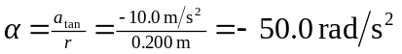 b) At 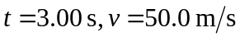and 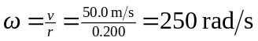 and at 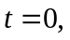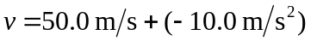
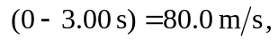so 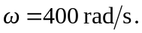 c) 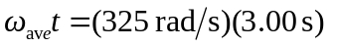
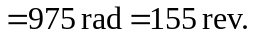 d) This speed will be reached at time . (There are many equivalent ways to do this calculation.)

